Wellness Clinic Medical Group - Team 10

Sagar Devkate, Carlos Flores, Christina Hyman, Daulet Kapezov, Zallocco Filippo

CS 623: Database Management Systems

Dr. William Buttgieg

September 19, 2022

**Step 1.1 – Format of input documents**

The following forms are used to provide information.

1. **Physician’s Statement for insurance** In this visual, we appreciate that Wellness Clinic physicians prepare statements for insurance companies regarding the services provided to either the insured or a customer on the insured’s plan. Besides patient’s information and Physician’s, we also find that data relevant for the insured’s payment plan with their provider. For example, Wellness Clinic includes the physician’s SSN for tax purposes and whether they are the patient’s primary care physician. Moreover, we learn that a Wellness Clinic is required to breakdown the purpose of the visit, type of examination conducted, type of condition, and further actions taken, such as treatments and recommendations. Finally, the clinic adds the total amount of the services provided to the insured or insured’s dependents, amount paid, and outstanding balance.

**Figure S.1**

**Figure S.1a**

1. **Patient Monthly Statement** In this visual, we find that Wellness Clinic breaks down in detail the services provided to the customer along with the amount charged per service, amount paid by the customer, amount covered by the insured, and total outstanding. The reason why the Clinic issues a statement every month is that often customers are on a payment plan with their insurance provider and will not pay their total amount on the date the service was provided. Thus, the clinic still offers healthcare services to all regardless of their ability to pay and serves most customers on credit as some of the bill will be paid later either by the insured or insured’s dependents. Those who do not have insurance or cannot pay for the service and qualify for state coverage will have their bill paid by the state.

**Figure S.2**

1. **Prescription Label and Receipt** This document will be used to provide billing information on any prescriptions issued by the clinic. Additionally, it provides patient information on the medication, instructions for consuming the medication, the issuing provider of the medication and the number of refills, if any. The receipt information provides the clinic’s contact information, method of payment (i.e. out of pocket, insurance co-pay), what the medication is and the dosage.

**Figure S.3**

1. **Weekly Coverage Schedule** The weekly coverage schedule is created by the Office Administrator. It highlights the medical and non-medical staff that will be on duty for each given day of the week and what times. It lists the phone numbers of the staff, their contact information, and who will be on emergency duty (colored blue).

1. **Daily Master Schedule** provides a breakdown of the hour by hour of each practitioner that is in for the given day and the timeslots for their appointments (if it is red, then this day is full) . Each practitioner has walk-in hours which are also listed in the daily master schedule.

**Figure S.5**

1. **Individual Practitioner’s Daily Schedule** Each practitioner will receive an individual schedule daily. This document will list who the patient is, the nature of their visit, time of their appointment, and which room they’re located in. For walk-in patients the nurses will update the practitioners schedule and provide the information as the patients are seen.

**Figure S.5**

1. **Operating Room Schedule** The operating room schedule lists the surgeries for the given month. It lists the surgeon, assisting nurse, patinent, and surgery type. It lists the time and date and is highlighted on the calendar to provide maximum clarity.

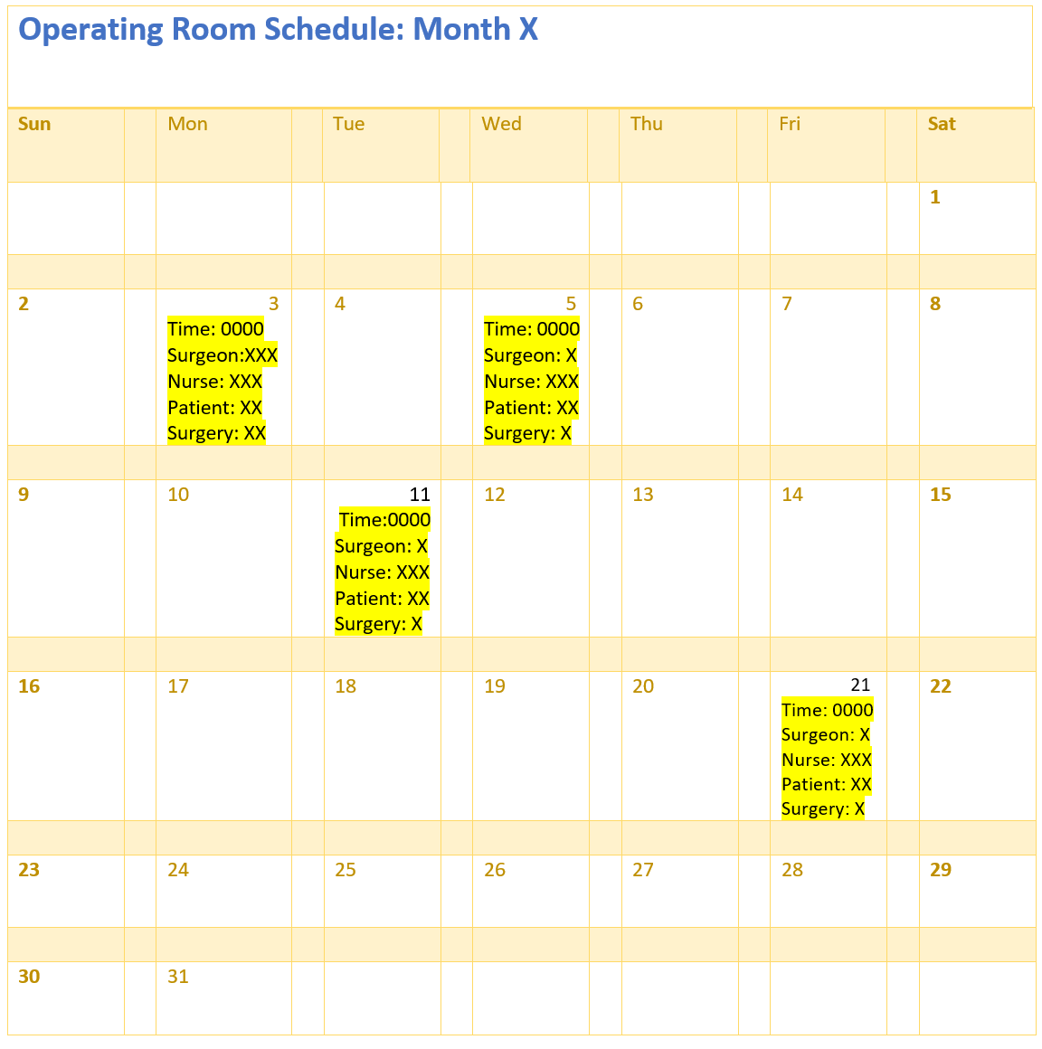

**Figure S.7 Operating Room Schedule**

**Step 1.2 Format of Routine reports**

The following reports are either currently in use or will be created by the new system.

1. **Daily Laboratory Log** For each day the medical tech will fill this out based on the test he or she conducted to later be documented.

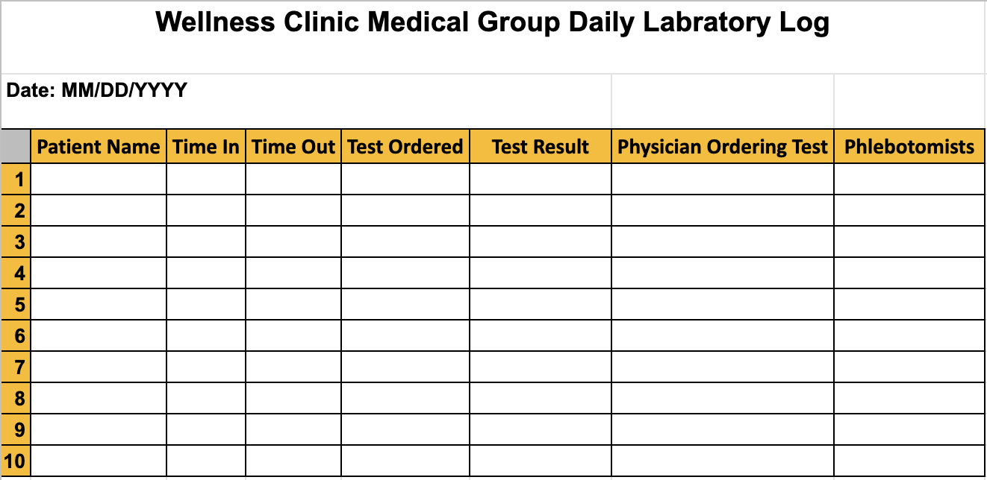

**Figure 2.1**

1. **Operating Room Log** The operating room log will be filled by the nurse or practitioner and later uploaded by the receptionist. It will provide the information of the surgeries conducted or surgeries that are pending operation and a list of the medical staff that performed the surgery and any additional observations.

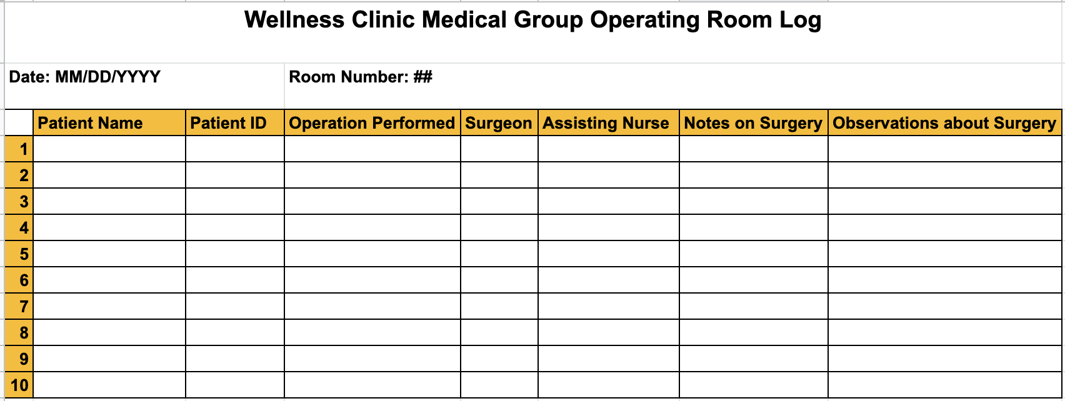

**Figure 2.2**

1. **Daily Delivery Room Log** will provide information on births at the clinic, this will provide details on the newborn's weight, medical staff present, and any additional comments such as complications.

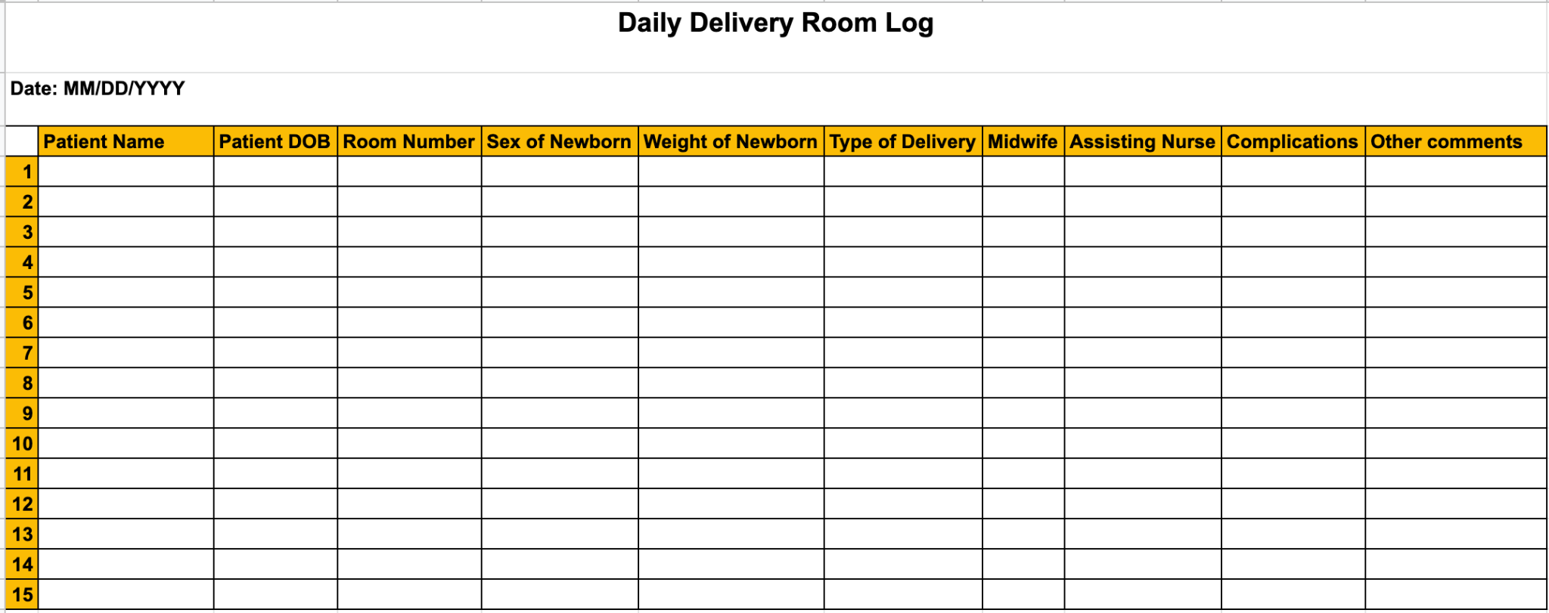

**Figure 2.3**

1. **Monthly Activity Report** This is a summary of the patient related activities conducted in the clinic each month. The office administrator will update this report and push it out to the medical staff within the first week of each month. The report provides the number of patients that visited, patients per practitioner, surgeries, lab tests by type and how many, births, and medication dispensed.

**Figure 2.4**

1. **Recovery Room Log** provides information on the patient and their current health state. It points out the vitals, their level of pain, diagnosis, allergies, medication history, and their current provider.

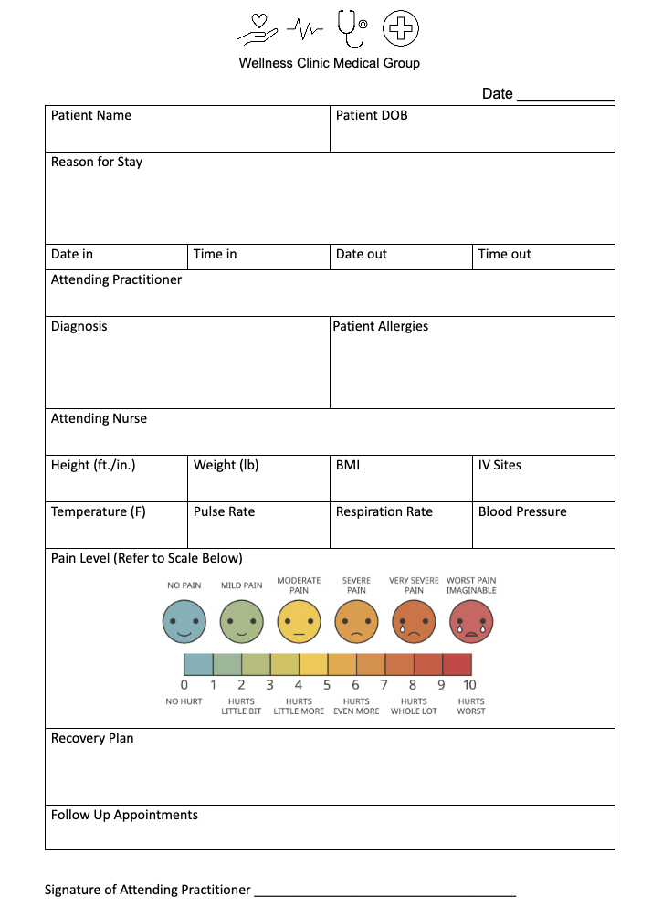

**Step 1.3**

**Patient Check-In**

For all transactions the user is instructed to choose from two transactions, “walk-in” or “appointment.” Either option will provide a follow-up screen asking if the user is a returning user or a new user. The existing user will ask for the last four digits of a tax ID or social security number along with last name. The user will confirm their information is up to date (phone number, email, address, insurance status/number) , receive a ticket number and wait to be called by a nurse or medical tech. Those that are first time visits at the clinic will fill out their personal data and will then be issued a ticket and will be called by a nurse.

The receptionist will act as QA/QC ensuring the system is updating as the patients check in. In the event the check-in fails the receptionist will check-in and it will notify the practitioner on duty in their individual schedule that patient X is at the clinic.

**Labs and Prescriptions**

The internal operations for the clinic will allow the practitioner to input any live labs and prescriptions internally to maximize the efficiency of the patient visit time. Once the practitioner inputs the lab test or prescriptions needed the pharmacist or lab technician will be able to prepare things for the arrival of the patient to process any test and distribution of medication.

**Step 1.4**

1. All staff including doctors, nurses, and/or part-time staff are not guaranteed to stay. They may either resign or be fired based on circumstances and situations
2. Staff may have to call out sick, so issues of being understaffed may arise.
3. For privacy reasons, the Health Insurance Portability and Accountability Act (HIPAA) is enforced to protect the rights of individuals and entities from unlawful discrimination and to regulate the use and disclosure of protected health information.
4. Patients will hold different types of health insurance plans including Affordable Care Act (ACA) Plans, Medicare, Medicaid, or health insurance plans through employers (e.g. HMO, PPO, EPO, or POS).
5. A procedure may take longer than the allocated time depending on complications.